COMPLAINTS POLICY AND PROCEDURE
_______________________________________________________________
RATIONALE
Magic Garden believes families and teachers should feel able to come forward with any concerns and complaints and that these are acknowledged respectfully. Fair and consistent procedures will be followed in seeking a resolution.

TE WHĀRIKI
Belonging/ Mana whenua - Goal 2: Children and their family experience an environment where they know that they have a place.

Complaints against Staff and Centre Procedure
- Resolving concerns and complaints is important to us as we want to provide the best for our families. Any concerns and complaints will be taken seriously and follow the ‘complaints flow chart’ on the next page.
- In the first instance talk to the person involved, this may be the key kaiako of your Child, if you are uncomfortable doing this, talk to your room’s supervisor.
- If action needs to be taken by the whole teaching team, all Kaiako/teachers will be made aware of the general nature of the complaint, but strict confidentiality to protect all stakeholders will be maintained.
- If the concern/complaint is about a teacher, the teacher will be informed as soon as possible before an investigation begins and advise sought from the Centre Manager before responding to the complainant.
- Documentation relevant to the issue at hand will be gathered and accurately recorded by the supervisor or Centre Manager as appropriate.
- Issues raised will be addressed in writing as soon as practically possible (within three working days).
- Confidentiality will be maintained where possible and in accordance with the Privacy Act 2020.
- Anonymous complaints will not be actioned.
- See flow chart on the next page for a step-by-step guide towards resolution of complaints.

LINKS TO:  - Child Protection Policy  - Individual Employment Agreement | Date approved:  Review date: 14th Feb 2022

Magic Garden believes families and teachers should feel able to come forward with any concerns and that these are acknowledged respectfully. To ensure all facts are understood and to provide opportunity for feedback, the complaints process should be followed sequentially, ensuring fair and consistent procedures are followed in seeking a resolution.

YES
Speak to the person involved, this may be the key kaiako of your Child.
Has the issue been resolved?
Complaint resolved.

NO
YES
Complaint resolved.
Speak to the Supervisor.
Has the issue been resolved?

YES
NO
Complaint resolved.
Speak to the Centre Manager.
Has the issue been resolved?

NO
Your written complaint will be acknowledged when received.
Put your complaint in writing to the Centre Manager and Owners of Magic Garden.

You will receive a letter addressing the complaint within 3 working days.
Letter will include one or all of the following:
- An immediate solution
- An action plan for resolution
- A meeting time to discuss
Complaint resolved.

Complaint resolved.
Attend meeting if requested.

If required, the Ministry of Education can be contacted directly if you wish to complain about non-compliance with the Regulations or criteria.
For more information visit www.minedu.govt.nz or (09)6329400

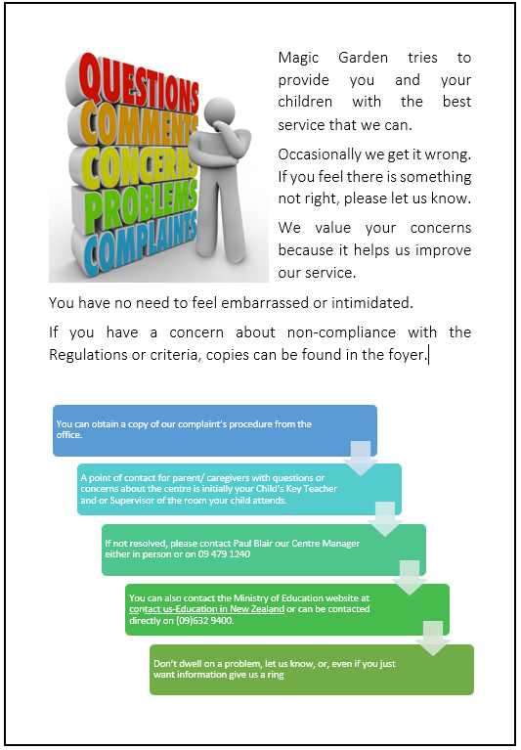
Information for Handling Complaints

Handling Complaints
This guidance is based on information on the Ministry of Education’s Educational Leaders website. (http://www.educationalleaders.govt.nz )

When you receive a complaint
a. Listen
- Let the complainant have their say. Make it clear that you have heard the complaint. Say something like, “Thanks for letting me know. I’ll follow this up and get back to you by ........…” Name a time that is easy to achieve and contact the complainant with your progress report towards resolution of the issue.
- Make the complainant feel that you value their coming to you. Do this even if they are angry. Remain calm even if what is being said seems unfair. You are the one in control of the situation.
- Write down the specifics of the complaint. You might need to get the complainant to pause while you gather things to write with.
- Check back that you have the details right. If it seems appropriate, ask them to write down the complaint as well, so that you can compare what you have written with what they said. Keep this written documentation safe, as you may need it later.
b. Investigate
- Depending on the nature of the complaint, you will probably not need to respond straight away, other than to thank the complainant for letting you know. However, if you deem the complaint to be 'serious' (for example if it involves the safety of a child or staff member), you may need to take immediate action before you can begin an investigation. This may involve the removal of a person or contacting external support. Do not assume blame on anyone’s part until you have gathered all the facts.
- Make a judgment call about the time you need to give to dealing with this complaint. Is it something that you can leave for a little while, or something that requires 'nipping in the bud' now? Ask yourself what the consequences of not dealing with the complaint immediately are likely to be.
- It is possible that the complainant will want an instant response. Reassure them that you will give them a response as soon as you have had time to consider it. Use this time to assess the gravity of the complaint, and then you can prioritise it. Don’t leave dealing with it for too long, though. Small issues can grow out of all proportion if they are not dealt with smartly. The priority scale you might use will probably be now, later today, tomorrow or the day after, rather than next week. Inform where necessary.
- Let everyone (who needs to) know what is going on. Any staff member who is the subject of a complaint must be told about it and any likely investigation of it as soon as the complaint is received.
- Keep those who are affected informed about what is happening (especially if the investigation takes longer than expected). Clear communications will help people to feel confident that you are handling the situation appropriately.
- Taking too long to act invites speculation and encourages those who don’t need to know to become involved.
d. Get advice
- Be aware of where you can receive support for managing complaints. This might be:
  - Any ECE member group you belong to,
  - An employer support organisation (eg Employers and Manufacturers Association, EMA),
  - Your local Chamber of Commerce or small business support group, o The Employment Relations Service of the Ministry of Business, Innovation and Employment. (http://www.dol.govt.nz/er/ )
  - The Ministry of Education.
- For more serious complaints involving staff that may develop into a competency or disciplinary situation it is advisable to ensure you are well informed of the legal processes you need to follow.
- Procedure must be strictly followed, or you might find yourself in an employment-related situation. There are many examples of employment related case law where the court has found in favour of the employee because of a failure of the employer to follow a fair process.

When you have the evidence
- Keep a record of everything.
- Consider all possible resolutions and possible unintended outcomes. You might want to discuss these with a trusted colleague.
- Meet with the complainant to convey your decision or to discuss the options for resolving the issue.
- If the complaint involves two parties (that is, one person complaining about another person) you might need to decide whether to bring the parties together to try to achieve a resolution. Depending on the seriousness of the complaint, you might need assistance to plan and manage this process. Again, use one of the services available to you. However, in more difficult cases this may not be an option.
- Make a decision. Acknowledge any ‘errors’ made, if necessary. Ask the complainant whether he/she is happy with the outcome. If not, offer further options that may be taken.
- Follow up with a letter to the complainant detailing the discussion, the agreement (if any) you have reached, and the intended actions.

Is it a complaint?
- It is not always obvious when someone is making a complaint, so be alert to this possibility. Ask, “Are you making a complaint?” and make a note of the response you receive. Complaints can be made in the form of 'softly presented' expressions of concern about something or someone. These can often be missed by busy principals and grow in seriousness. If this happens, a complainant could justifiably say, “I asked you to do something about this 6 months ago!” However, you don’t want to be over-reactive, so seeking clarification at an early stage is important.
- If it seems ‘tricky’, don’t hope it will just go away. It won’t.

Involving the centre owners
If the complaint is made to you, use your judgment. Try to achieve resolution at the lowest level possible.
If you think things might escalate, advise the centre owners of the measures you’re taking so that he/she will not suddenly be surprised by what has become a major concern. You may also need to alert the service’s insurer if the complaint is ‘high level’ - for example, if it could become a personal grievance case.
If the complaint is made to the centre owners, it’s not your decision. You will play whatever role the centre owners require of you. For example, you might be asked to gather and pass on the evidence. If you collect and present the evidence, natural justice says you should not be involved in any judgment – let the centre owners make the decision.
If the complaint is about you, the executive/board must handle it without your involvement, but with your knowledge.

